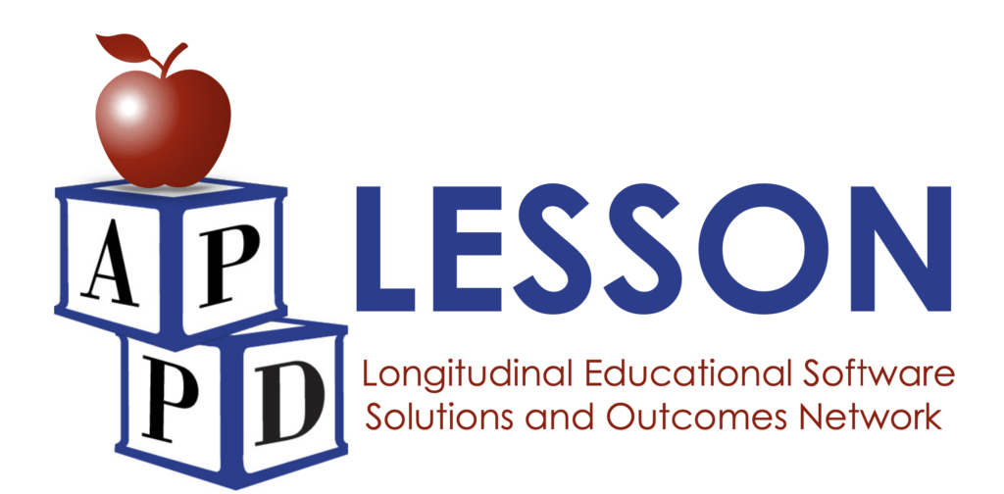
LESSON Curriculum Development Submission Template

Title of Curriculum:

Course description A VERY brief description of the course content, typically 1-2 sentences.

Overall Course Goal: Provide a detailed description of what will happen in the course, including topics to be covered.

Student Learning Objectives Please list specific, measurable, and observable skills that the students will be able to demonstrate by the end of the course. If several topic categories/modules, provide learner objectives for each.

Background and rationale (2 page limit).
Explain why this curriculum is important and needed, and how this will address gaps found in existing literature or needs assessments. In reviewing the literature, be selective, rather than exhaustive, favoring the most important previous work.

Modality Is this course 100% online? o Yes o No
If proposing a hybrid curriculum, please describe local site portion of your curriculum.

Evaluation (2 page limit) Describe how the curriculum will be evaluated. Include any data collection requirements. When and how often will data collection occur for each learner?

Eligibility. Please explain, in detail, the target audience including any enrollment restrictions, exclusions, etc.

Project Lead and Subject Matter Experts (1 page limit). List the proposing project lead and other subject matter experts. For each, briefly list their qualifications and explain their role in the project.
NOTE:
- The Project Lead must complete the APPD LESSON Scope of Work Agreement.
- All subject matter experts and curricula content contributors must complete the APPD Intellectual Property Agreement upon selection.

Timeline In your estimation, how long will it take you to develop the course materials ready to be imported into an online modality? Include your ideal “Go Live” date.

Appendices (upload separately)
- Curriculum Outline
- Copies of all assessments
- Biosketch of project lead (NIH format encouraged: http://grants.nih.gov/grants/funding/phs398/biosketch.doc)

