Struggling Learner
Nathaniel Goodrich, MD, Nicola Orlov, MD, David Mills, MD, Elizabeth Nelsen, MD, and Su-Ting Li, MD, MPH
Edited by Caren Gellin, MD and Daniel Sklansky, MD

Introduction
While the exact rate of remediation is not well-reported in the literature, studies from surgical specialties, internal medicine, family medicine, and emergency medicine suggest a wide range, with 2-31% of residents requiring remediation. A 2013 study of pediatric program directors estimated that up to 12% of pediatric residents may require remediation.
Definitions
While there is no single, standard definition, remediation is generally defined as any form of additional goal-directed training, supervision, or assistance beyond what is typically required for a resident in a given specialty and in response to suboptimal performance in a given core competency. Two levels of remediation are widely recognized: informal and formal.
Informal remediation is typically managed internally by the residency program and is aimed at improving performance by a learner; this is not typically reported in any official capacity in future performance reports for the trainee.
Formal remediation, however, occurs when a resident’s performance or conduct no longer meets the requirements of the program, may include unsuccessful efforts of informal remediation, and may involve formal notification to the resident with support from the institutional GME office. This formal remediation may be reportable on future reference letters and, in rare circumstances, may result in probation or termination from the program.

Remediation in Pediatric Residency Programs
In 2022, a national survey of pediatric residency program directors revealed that professionalism is the most commonly reported area requiring formal remediation (73%). Medical knowledge (67%) and interpersonal and communication skills (57%) are also commonly reported areas that require remediation. Less commonly, problem-based learning and improvement (21%), patient care (10%), and systems-based practice (6%) were identified as competencies requiring remediation.

Notification to the Resident

Important Components:
- Regular documentation of a resident’s deficiencies is essential and should be included in the resident’s file. This documentation may include written evaluations, e-mailed concerns, documentation of concerns from the CCC, summaries of meetings with the resident discussing the remediation plan/progress made, etc.
- The resident should be informed of the need for remediation in person and in writing. It may be helpful to have the resident’s advisor/advocate present for this meeting. The resident should sign and date a formal document acknowledging they received notice of their need for remediation. By signing the document, the resident is acknowledging receipt of the remediation document. The letter/memo should also be signed by the Program Director (and, at certain institutions, the Designated Institutional Official).
- The letter should explicitly describe concerns, preferably documenting where these concerns were raised (e.g., faculty evaluations, CCC documentation, peer evaluations, e-mail, etc.), reference which core competencies, milestones, and/or EPAs the resident was not meeting, explicitly state the program’s performance expectations, how the program will monitor the resident’s performance moving forward, when the PD will meet with the resident to discuss progress in meeting the expectations, and any other expectations, meetings, and duties relevant to the remediation plan.
- The resident should be provided with program and institutional grievance and due process policies.
- A copy of the signed letter should be kept in the resident’s permanent file. Oftentimes, a copy of the signed letter should also be sent to the DIO, Human Resources, and/or Chair. The GME office (and DIO) should be notified.
- The length of time for remediation must be determined, including a target end date.
- A focused plan with documented deficiencies and expected outcomes must be created. There must be specific targets based on the deficiencies.
- The time frame for reassessment and the possible outcomes of the remediation plan must be discussed.

Terminology and expectations for these letters may vary between institutions. Generally, institutions may have one type of letter for informal remediation (e.g. Letter of Expectation, Letter of Improvement) and another for formal remediation (e.g. Letter of Warning, Letter of Probation). PDs should consult with their GME office to ensure the title and content of their letters is appropriate for the situation.

Developing a Remediation Plan
Conceptual Framework
Qualitative data were also collected with the survey to determine how programs identify, support, and monitor residents requiring remediation. Utilizing this information, a conceptual framework was developed by which to approach resident remediation (Figure 1). A remediation plan should be personalized to the individual trainee and their learning needs. Implementation of this personalized plan should occur in a stepwise fashion with four separate phases, with each phase focusing on competency attainment while maintaining psychological safety.

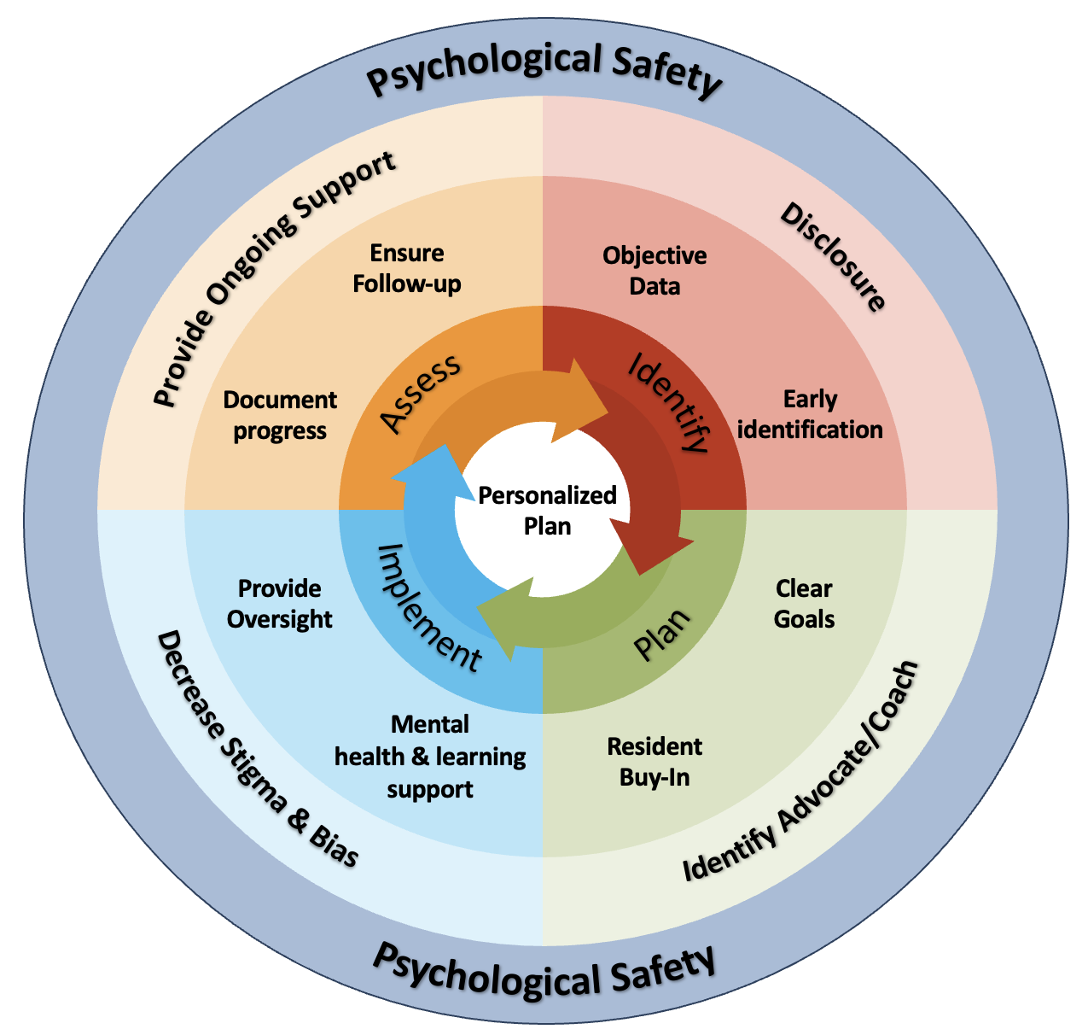
Figure 1: Conceptual framework that can serve as a guide through the remediation process.

Psychological Safety
When a resident is identified as needing remediation, the stress and emotional burden on that trainee is immense, with a considerable amount of guilt and anxiety. To combat these emotional reactions and the subsequent anxiety, fear, and sense of impostor syndrome that can develop for the remediating resident, PDs need to create an environment where they view their learning plan as an opportunity to grow, rather than a punishment. Providing extensive support to the struggling learner and destigmatizing remediation are key to creating psychological safety. Establishing an environment of transparency and honesty and taking a nurturing approach can help decrease the negative emotional reactions to remediation, thereby demonstrating to a resident that they have the full support of residency program leadership. Highlighting the positive achievements of a resident during their remediation journey can also contribute to establishing psychological safety.
Phases of a Remediation Plan

Identify
PDs recognize that if a trainee can be identified early, it allows more time for intervention and support. Objective data should be used whenever possible to illuminate where the deficits exist. Utilizing the pediatric milestones and EPAs and direct observations to identify deficiencies is recommended. Sources of objective information may include:

Clinical competency committee assessment | Rotation evaluations
Direct observations | Verbal feedback
Milestone scores | Multi-source/360 evaluations
In-training examination score | Entrustable professional activities

PDs highlight the importance of having an open and honest disclosure conversation with the trainee once the need for remediation has been identified. Struggling trainees are not always aware of their perceived weaknesses, but PDs rely on early and frank conversations to help gain resident engagement and buy-in during the remediation process.

Plan
Developing clear goals is important in helping the resident understand their deficiencies. During this process the PD and the trainee should engage in shared decision-making about what the trainee needs to be successful, both academically and emotionally. The conversation should be grounded in the objective data gathered during the identification phase and should focus on developing clear goals for the trainee that are both measurable and attainable.

Components that may be included in a remediation plan, depending on the specific deficiency:

Assignment of mentor/coach* | Direct observations of patient care
Increased frequency of feedback/evaluations | Modification of block rotation schedule
Referral to mental health evaluation/counseling | Repeating rotation(s)
Assigned reading material | Referral for neuropsychiatric/education evaluation
Referral for medical evaluation/treatment | Board prep questions
Observed practice of oral presentations | Removal from rotations to focus on plan
Multi-source/360 evaluations | Trainee shadowing of other residents/faculty
Protected time during rotation to focus on plan | Standardized patient encounters
*Assignment of a coach/mentor as the resident’s advocate is an essential component of any remediation plan to build psychological safety.

Implement
The importance of separating those in charge of oversight from the resident advocate/coach is critical to ensure that decisions are being made in an unbiased fashion while sustaining the resident’s support system. Oversight of the remediation plan may be provided by the Clinical Competency Committee (CCC), the institutional Graduate Medical Education (GME) office, or in rare cases, the medicolegal team. Documentation of progress can occur in the form of a written improvement plan or a letter from the PD, CCC, or, less commonly, the GME office.

Diagnosis, intervention, and support for any learning differences or mental health needs may be limited by stigma, but targeted support can be instrumental in providing successful remediation. These resources may vary by institution, so PDs should contact their local GME office to determine what might be available and appropriate.

Assess
PDs must ensure follow-up during the assessment phase of the remediation process. Setting “fixed” intervals of check-ins can help ensure regular review of evaluations and ongoing discussions of progress with the resident. The vast majority of PDs follow-up in either weekly, every other week, or monthly intervals. While the length of a resident’s remediation plan will be individualized to their situation, most PDs utilize a 3-month duration before deciding the next course of action (e.g. continued remediation, successful completion of remediation, probation, etc.).

Outcomes to a Remediation Plan
Successful Completion
A resident who has met the goals outlined in the remediation plan should be notified of their successful completion by those overseeing the plan both verbally and in writing. Appropriate documentation of success should be reviewed with the GME office. Remediation that is successfully completed generally does not need to be reported for any future licensing/credentialing needs, though will depend on the nature of the remediation.

Extension of Remediation Plan
If, at the end of the evaluation period for the resident’s remediation plan, it is felt that the resident has made significant progress but has not fully met the outlined goals, extension of the remediation plan may be considered. Those providing oversight should provide transparency regarding areas needing ongoing remediation, and a new remediation plan should be created with well-defined goals and a firm timeline.

Probation/Letter of Warning
If a resident does not meet the required goals outlined in their remediation plan, they may need to be placed on probation. PDs should consult with their institutional GME office if this is necessary, as this action may be reportable in the future and could require more extensive documentation.

Extension of Training
In some cases, residents may not perform adequately enough on a rotation to “pass” the rotation. Should a resident require extension of training because of this, or because of the nature of their remediation plan, the PD should consult with both their institutional GME office and the ABP to determine what implications this may have, as each scenario is unique. Extensions of training and marginal/unsatisfactory performance need to be documented and reported to the ABP.

Non-Renewal/Termination
Rarely, a resident may not be successful despite extensive support, coaching, and mentorship. In these cases, PDs should consult with their GME office regarding options for non-renewal of the resident’s contract or even termination from the program. These decisions will often involve the institution’s legal team, the GME office, and the DIO, and policies/documentation may vary between institutions. As noted above, objective documentation of the resident’s progress, or lack thereof, will be critically important to this decision making.

Resources

Link to example letter of improvement

Link to example letter of warning

Link to example improvement plan

Link to larger version of conceptual model

ACGME Remediation Toolkit: https://dl.acgme.org/courses/acgme-remediation-toolkit

Smith, Jessica, Monica Lypson, Mark Silverberg, Moshe Weizberg, Tiffany Murano, Michael Lukela, and Sally Santen. “Defining Uniform Processes for Remediation, Probation and Termination in Residency Training.” Western Journal of Emergency Medicine 18, no.

