**Residents and the American Academy of Pediatrics (AAP)**

Aaron R. Shedlock, MD and Sara Multerer, MD

Edited by Rebecca Wallihan, MD and Elizabeth Nelson, MD

Introduction

The American Academy of Pediatrics (AAP) is the core organization that unites current, former, and future pediatricians all over the country regardless of their practice type or specialty. This organization provides a wealth of knowledge, education, resources, advocacy, and support “dedicated to the health of all children.” As members, trainees will benefit from numerous clinical materials, journals, guidelines, quality improvement training resources, educational courses, board review questions, and scholarships available to further their training and set the stage for a successful future career in partnership with the AAP.

Resident Membership

Pediatric residents and fellows can join the AAP at a reduced rate. To qualify for the “in-training” membership rate, individuals must be enrolled in an ACGME-accredited training program. As AAP members, residents have free access to many benefits including: learning tools such as PREP (Pediatrics Review and Education Program) The Curriculum Self-Assessment, [*AAP Grand Rounds*](https://publications.aap.org/aapgrandrounds), and [*Pediatrics in Review*](https://publications.aap.org/pediatricsinreview); journals such as [*Pediatrics*](https://publications.aap.org/pediatrics); textbooks such as the [*Red Book*](https://publications.aap.org/redbook?autologincheck=redirected); advocacy tools such as the Advocacy Action Center; opportunities for section, council, or committee participation; and savings programs, such as loan consolidation. There are many additional benefits typically offered by AAP local chapters as well. A full list of resident and fellow benefits can be found [here](https://www.aap.org/en/membership-application/residents/).

Residents and fellows can join as individuals or, if the program has resources to pay for trainee memberships, a program can become a “[Dues Sponsoring Organization](https://collaborate.aap.org/DSO/Pages/HomePage.aspx).” This set up allows programs to create memberships for their trainees in bulk and have access to program views of resident participation in AAP learning activities such PREP or Individualized Learning Plans (ILP) (see the PediaLink section below). Enrollment of new resident memberships usually starts in the spring, shortly after Match Day. Dues are typically due in early summer before July 1st.

**Additional Membership Benefits for Residents:**

* Section on Pediatric Trainees ([SOPT](https://collaborate.aap.org/SOPT/Pages/Home.aspx)): This section of the AAP is the home base for medical students, residents, and fellows and offers many opportunities for trainees to become advocates and leaders. This section offers funding and grants (see the Grants and Scholarships section) and leadership positions at both the district and national level. Residency programs can nominate a SOPT delegate (and an alternate), who will attend the AAP National Conference and Exhibition each year and act as a liaison between the AAP SOPT and the residency program. The SOPT delegate typically should be named to the AAP by the end of July each year, and programs should have a process in place for choosing this person.
* Advocacy Resources: The SOPT often sponsors a [national advocacy campaign](https://collaborate.aap.org/SOPT/Pages/SOPT-Advocacy-Campaign.aspx) that trainees can be a part of. The AAP also offers other general advocacy resources by topic, including common state issues and federal advocacy blueprints. The new [Digital Advocacy Guide](https://www.aap.org/en/advocacy/aap-advocacy-guide/) is an all-encompassing resource for any pediatrician.
* Leadership Opportunities: Resident and fellow trainees can participate in any section or council of the AAP as a member and can also get engaged with the [AAP Volunteer Network](https://collaborate.aap.org/AAP-Volunteer-Network/Pages/Volunteer-Board-National.aspx). As above, residents and fellows have many [opportunities for leadership within the SOPT](https://collaborate.aap.org/SOPT/Pages/Leadership-Opportunities.aspx) with executive committee, liaison, and working group positions open each year.

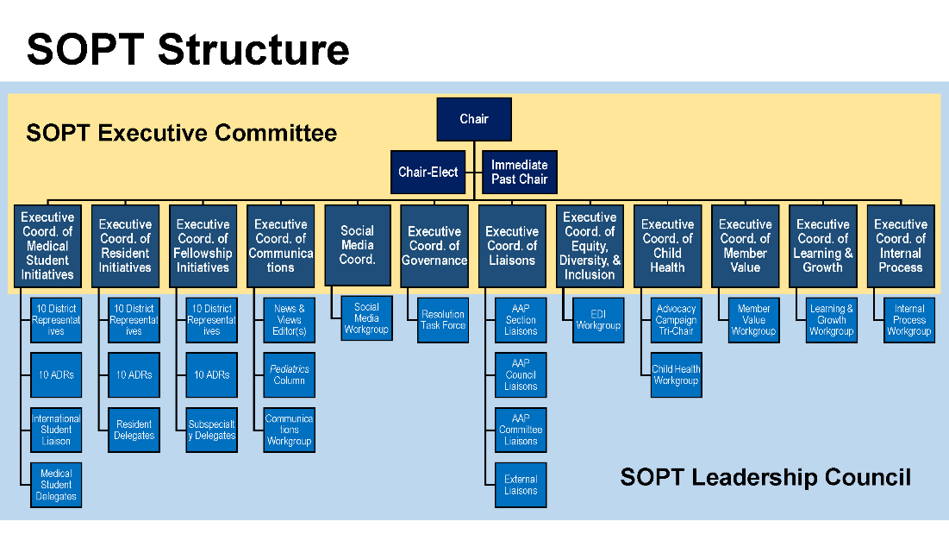

Website Resources

A few other key resources that the AAP provides for pediatricians that are very relevant to residents include:

* [Career resources](https://www.aap.org/en/career-resources/)
* [Journal subscriptions](https://www.aap.org/en/shopaap/shop-by-product/journals/)
* [Patient care resources](https://www.aap.org/en/patient-care/)
* [HealthyChildren.org](https://healthychildren.org/English/Pages/default.aspx) – Resources for patients (and young resident parents!)

Grants and Scholarships

The [AAP Section on Pediatric Trainees (SOPT)](https://collaborate.aap.org/SOPT/Pages/Home.aspx) has numerous yearly [funding and award opportunities](https://www.aap.org/en/community/aap-sections/pediatric-trainees/sopt-funding-and-awards/) not limited to:

* Advocacy Conference Scholarships – applications in January
* Child Advocacy Award –applications in April through June
* Clinical Case Competitions – applications in February through April.
* Community Access to Child Health (CATCH) Resident Grants – applications in November through January
* Financial Hardship Grants – applications in April
* Health Equity Grant Programs – applications in November through January
* International Elective Awards – applications in September and March (two cycles)
* Pediatric Hospital Medicine Conference Grants
* Program Delegate Awards – applications in August
* Resident Research Grants – applications in December through February

PediaLink

[PediaLink](https://www.aap.org/en/pedialink/) is the educational platform of the AAP website which offers trainees, program directors, and resident advisors numerous resources, if they are paid members of the AAP. Program coordinators of Dual Sponsoring Organizations have access to PediaLink, as well. Programs should notify the AAP of a program director change so that the PD has access to all the PediaLink resources. The PediaLink portal can be accessed by the PD logging in with their AAP username and password. PDs are granted access to residency program-specific data by clicking on “Manage Your Program.” In the PediaLink Online Learning Center, you will have access to three separate views/tabs:

* Pediatrician View – this view is available to any pediatrician with an AAP membership and includes access to CME activities/transcripts, educational resources, and career/leadership guidance.
* Program View – is a view unique to program directors, program coordinators, and trainee advisors that provides overarching access to your program’s resident data through various tabs:
  + **Home** – allows PDs to preview the educational courses, QI resources (EQIPP), and medical education resources all available to trainees for free through the PediaLink portal.
  + **Program Administration** – allows programs to add new trainees (e.g., after Match Day), delete trainees (e.g., after graduation), alter trainee biographical information, and assign trainee advisors. Assigning advisors will give advisors access to the Individualized Learning Plan (ILP) and Pediatrics Review and Education Program (PREP) performance reports for their assigned residents only.
  + **Learning Plan Manager** – is one way that residency programs can manage and operationalize the ACGME requirement of residents creating and updating individualized learning plans (ILP). This tab allows for programs to customize a learning plan for their program, view individual resident ILP’s, and run bulk resident ILP reports to export into an Excel file. The ILP’s allow residents to list their goals, assess their competencies against the ACGME milestones, and develop action plan items and strategies to meet their goals and improve competency.
  + **PREP SA Reports** – allows residency programs to view the progress and performance of individual resident on yearly PREP exams. By clicking the “view” tab next to a resident’s yearly test, a PD can see how a resident is performing on each test content domain which can be particularly helpful for monitoring board study plans and individual areas for improvement. The “Program Report” tab allows a residency program to view the performance of the residency in aggregate on each test content domain which may identify program weaknesses and guide didactic curricula or focused board prep.
  + **Quality Improvement** – allows residency program leaders to create and manage EQIPP (Education in Quality Improvement for Pediatric Practice) groups and run reports on course completion or QI project progress for the residents.
    - [EQIPP](https://pedialink.aap.org/File%20Library/Unassigned/EQIPP-for-Residents---User-Guide.pdf) provides residents:
      * Numerous free QI courses on a variety of topics, such as asthma management, URI management, oral health, Bright Future developmental screening, and immunizations. Resident progress in any assigned courses can be tracked here.
      * A platform to organize QI projects with other residents/faculty and a repository to store/analyze data for their projects.
* Resident View – is a view unique to program directors, program coordinators, trainee advisors, and residents that provides the PediaLink view that an individual resident will see during their residency with the following tabs:
  + **Home** – provides resident access to free AAP clinical courses, QI resources (EQIPP), and medical education resources.
  + **Individual Learning Plan** – provides resident access to building and updating their own ILP.
  + **PREP Self-Assessment** – provides resident access to any available PREP Self-Assessment questions. Please note that PREP is available for free as part of a trainee’s paid AAP membership. As long as they are a resident, the resident will receive a new set of PREP questions for free on January 1st of each year. Residents will always *only* have access to three years’ worth of PREP questions at any given time so encourage them to complete older PREP questions first. For example, an intern starting in 2024 will immediately gain access to the 2024, 2023, and 2022 PREP exams upon starting July 1, 2024 (if their AAP membership is paid on time). On January 2025, they will gain access to the new 2025 PREP questions (while maintaining access to 2024 and 2023 versions) but will lose access to the 2022 questions. Once a resident graduates from residency, they no longer receive PREP for free as part of an AAP membership but they will NOT immediately lose any questions they previously had access to so that they can continue to study for their board exam. They just will not receive new questions each January 1st going forward without paying separately for them even if they pay for an attending AAP membership. Graduated residents will gradually lose access to their free PREP questions obtained in residency after three years of access (e.g., the 2025 questions will expire on January 1, 2028). Graduates can use these questions for CME credit toward their medical licenses/renewals.
  + **Continuing Education** – provides resident access to all their completed PediaLink/ AAP-sponsored courses and tracks any CME credits allowing transcripts to be generated. This tab also provides opportunities to find any desired CME courses offered through the AAP.

The AAP provides a PowerPoint slide deck that can be used to educate residents and advisors on all the functions of PediaLink (ideal for new intern orientation or faculty development). It is best to email an AAP representative for the most updated version.

Resources

* AAP- <https://www.aap.org/>
* AAP Resident Membership Details - [Residents (aap.org)](https://www.aap.org/en/membership-application/residents/)
* PediaLink- <https://www.aap.org/en/pedialink/>
* Section on Pediatric Trainees (SOPT) - <https://collaborate.aap.org/SOPT/Pages/Home.aspx>